Bahria University,

Karachi Campus



LAB EXPERIMENT NO.

**07**

LIST OF TASKS

|  |  |
| --- | --- |
| TASK NO | OBJECTIVE |
| 01 | Analyze the above network, deactivate another working interface and monitor  the shift to the redundant interface. Also, change the root switch to a switch of your choice and implement the rapid STP and finally show the pinging results. |
|  |  |

Submitted On:

**06/12/2023**

**LAB 07 SPANNING TREES**

**TASK 01:** Analyze the above network, deactivate another working interface and monitor

the shift to the redundant interface. Also, change the root switch to a switch of your choice and implement the rapid STP and finally show the pinging results.

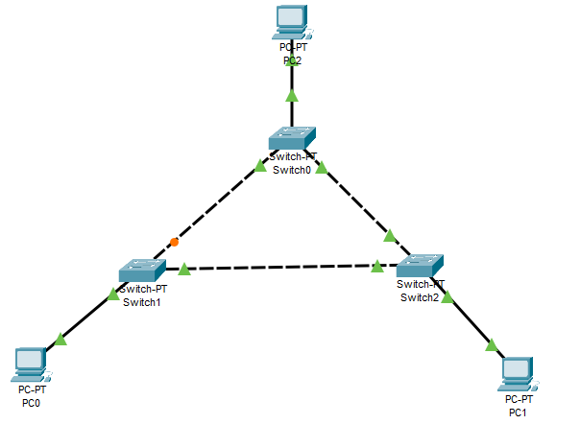

**Analyze the above network**

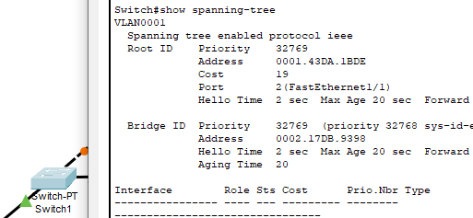 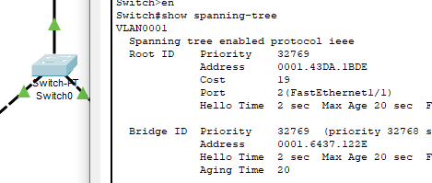

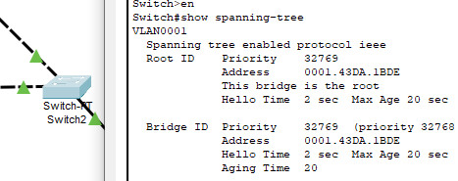

**Deactivate Another Working Interface**

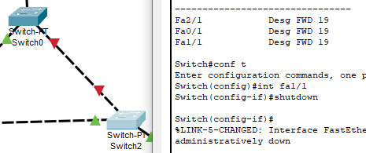

**Monitor The Shift To The Redundant Interface**

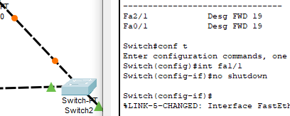

**Setting Root Method 1**

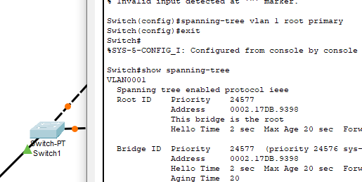

**Setting Root Method 2**

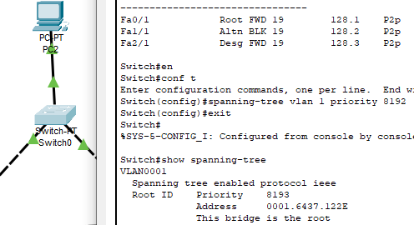

**PC2 TO PC0**

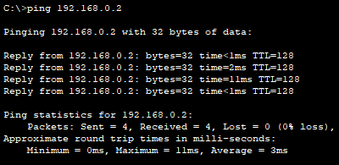

**PC2 TO PC1**

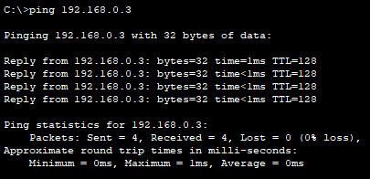

**PC0 TO PC1**

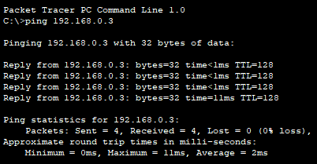

**PC1 TO PC0**

